# Sensor Breakout (ACS723)

<https://learn.sparkfun.com/tutorials/current-sensor-breakout-acs723-hookup-guide>

1. **Introduction**

The ACS723 is a handy little current sensor from Allegro MicroSystems for low to moderate current sensing applications. SparkFun offers two flavors of breakout board, [one with just the sensor](https://www.sparkfun.com/products/13679) and [another with an on-board amplifier](https://www.sparkfun.com/products/14544) to increase the sensitivity.

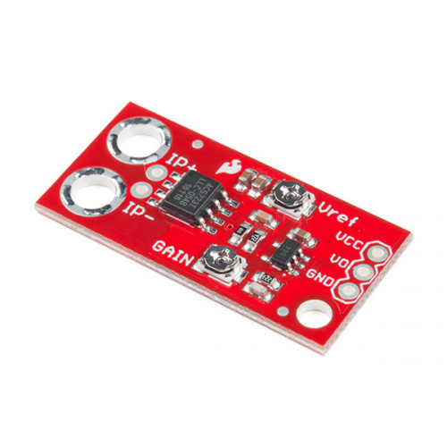

Sparkfun SEN-14544 ACS723 Current Sensor (Low Current)

The ACS723 sensor uses a Hall effect sensor to output a voltage relative to the current flowing through the IP+ and IP- pins. The advantage of using a Hall effect sensor is that the circuit being sensed and the circuit reading the sensor are *electrically isolated*. This means that, although your Arduino is running on 5V, the sensed circuit can be operating at higher DC or AC voltages!

The amplified breakout board (Low Current) is capable of sensing very small currents down to around 10mA and large currents up to 5A! However, since the output is analog, your usable readings will be limited by noise and the resolution of the ADC reading the output. This sensor is not recommended for current sensing lower than 10's of milliamps.

1. **The Hall Effect and Current Sensors**

The ACS723 has an internal Hall effect sensor placed next to the aforementioned copper strip. When current flows through this copper strip, a magnetic field is created. This magnetic field is then sensed by the Hall effect sensor and produces a voltage output that is proportional to the input current!

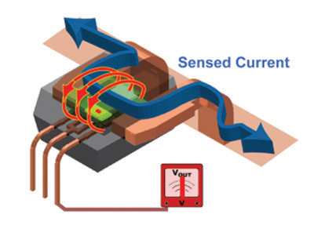

This method of sensing allows the sensing circuit to be *electrically isolated* from the sensed circuit. Practically, this means that since the circuits aren't physically connected, you can use a low-power Arduino to measure the current going through a high power device, even one that uses AC power!

1. **Hardware Overview**
2. **ACS723 Breakout Details:**

* **Analog output** with bandwidth adjustable to 80kHz.
* The bandwidth on the ACS723 Sensor Breakout width filter has been set to 20kHz to reduce noise when using at high gains.
* Measures DC and AC currents from around **10mA up to 5A**
* Full electrical isolation of measured and sensed circuits
* The version without the op-amp has a base sensitivity of 400mV/A

In addition to the above, the Low Current Sensor Board has the following:

* Adjustable sensitivity with on-board amplifier, gain from **2.2** to **22 V/V**

Below is a list of all the pins broken out on the ACS723 and their functions.

|  |  |
| --- | --- |
| **Symbol** | **Description** |
| IP+ | High side of current sensor |
| IP- | Low side of current sensor |
| GND | Must be connected to ground |
| Vo | Voltage output proportional to current flowing through IP+ and IP- |
| VCC | **5V** power supply |

To measure a current using this device, the current must flow through the IP+ terminal and out the IP- terminal (it will work in the other direction, but the measurement will be negative). IE: These terminals must be *in series* with the circuit that the measured current is flowing through. Note that both IP+ and both IP- terminals are connected to each other, you can use either (or both) of them.

1. **Amplification (Low Current Sensor):**

The amplified version of the breakout board [(ACS723-Low Current)](https://www.sparkfun.com/products/14544) has two potentiometers on it: ***Vref*** and ***Gain***.

The **Vref potentiometer** sets the baseline voltage output. In other words, it adjusts the voltage seen at Vo when there is no current flowing through the sensor (0 mA). This allows the sensor to output negative current readings as well as positive.

The **gain potentiometer** sets the sensitivity of the device. For example, if the gain is set high, then a smaller current will cause the voltage output to increase more, giving you higher sensitivity and allowing you to sense smaller currents.

**However,** there are a couple caveats:

1. With higher gain you will see more noise (spikes) on the output, so smaller currents will be harder to measure accurately.
2. If you are trying to measure larger currents with a high gain setting, your output will **saturate** or **clip** and reach the maximum 5V or 0V.

With that in mind, to get meaningful data from the current sensor, you must configure the *Vref* and *Gain* potentiometers properly.